Title of abstract for poster presentation
in 2022 spring conference of KSCSE
Author ¹, Author², and Author^{2*}
¹ Korean Society for Computational Science and Engineering, Daejeon 34141, Republic of Korea
² Korean Society for Computational Science and Engineering, Seoul 02455, Republic of Korea
Corresponding author (Electronic mail: aaa@cse.or.kr)
This template is for authors who are preparing a poster presentation in autumn conference of Korean Society for Computational Science and Engineering. The length of abstract should be no more than one page, including Title, Author information, Abstract, Figure (in preference), Acknowledgement (if required), and References.
The poster session will be held via on-line partly. All poster material including abstract will be posted on website. The authors should prepare presentation video whose length is 10 minutes and its short version within 2 minutes. (To be decided)
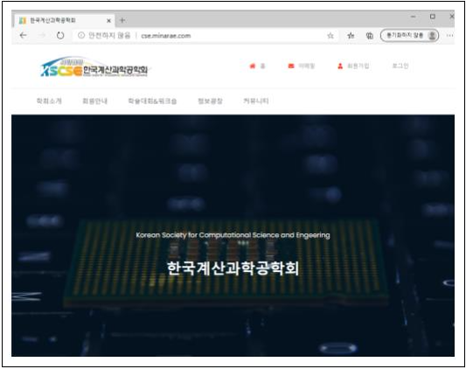
Figure 1 KCSCS website
Acknowledgments This work has been carried under the support of Korean Society for Computational Science and Engineering and Korea Institute of Science and Technology Information (KISTI).
References
[1] J. H. Kang et al., “Reference,” journal, 3, 3 (2020).

